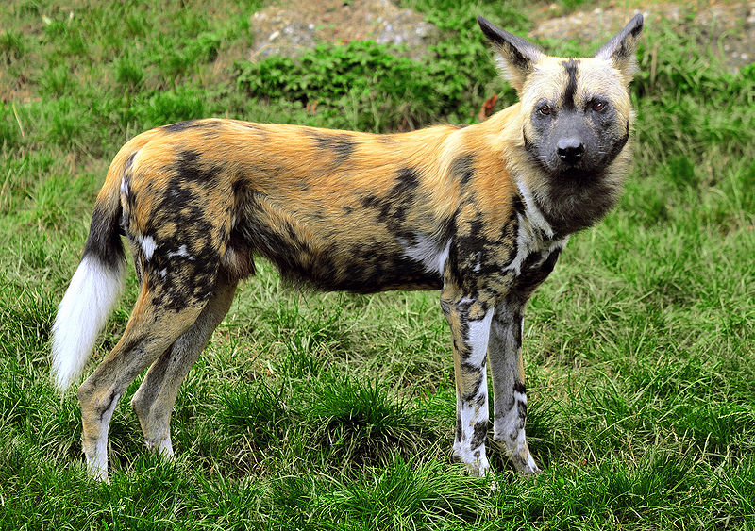  
COMMON NAME: African wild dogs

SCIENTIFIC NAME: Lycaon pictus

TYPE: Mammals

DIET: Carnivore

GROUP NAME: Pack

AVERAGE LIFE SPAN IN THE WILD: Up to 11 years

SIZE: 29.5 to 43 inches

WEIGHT: 39.5 to 79 pounds

SIZE RELATIVE TO A 6-FT MAN:

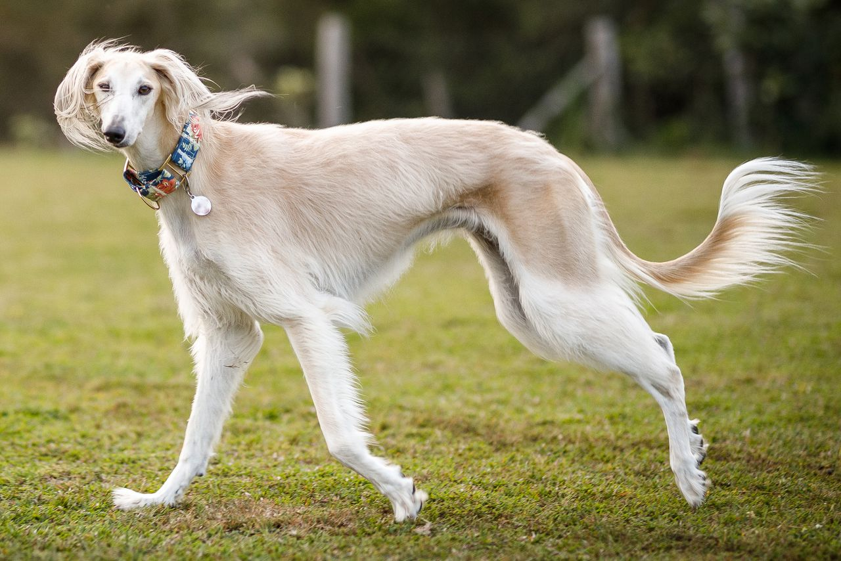

NAME:SALUKI  
GROUP: Hound (AKC)

HEIGHT: 23 to 28 inches  
WEIGHT: 40 to 65 pounds  
COAT AND COLOR: Smooth or feathered coat; colors include white, cream, fawn, golden, tricolor, and black and tan

LIFE EXPECTANCY: 10 to 17 years

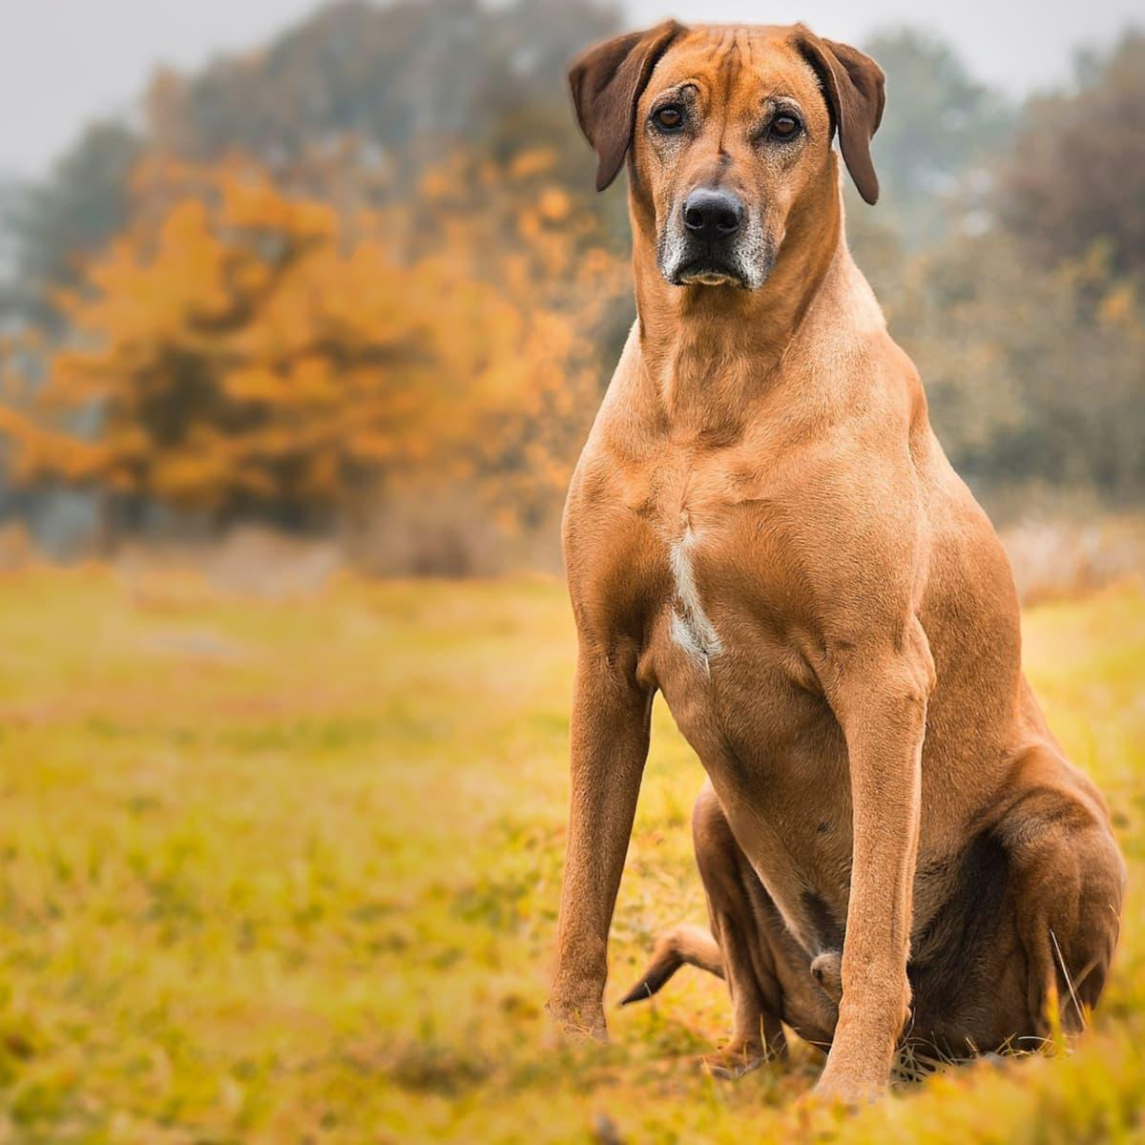

NAME:RHODESIAN RIDGEBACK  
GROUP: Hound (AKC)

HEIGHT: 24 to 27 inches  
WEIGHT: 70 to 85 pounds  
COAT AND COLOR: Ridge on their back; short and dense coat; colors range from light to red wheaten with small white markings on their chest and toes; may have a black mask

LIFE EXPECTANCY: 10 to 12 years

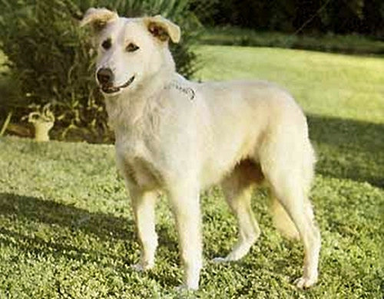

NAME:AIDI  
GROUP: Guardian (UKC), Molossian (FCI), not an AKC-recognized breed

HEIGHT: 20 to 24 inches  
WEIGHT: 50 to 55 pounds  
COAT AND COLOR: Thick, coarse coat of medium length; colors vary and can include black, white, red, and tawny; dark eyes

LIFE EXPECTANCY: 10 to 12 years

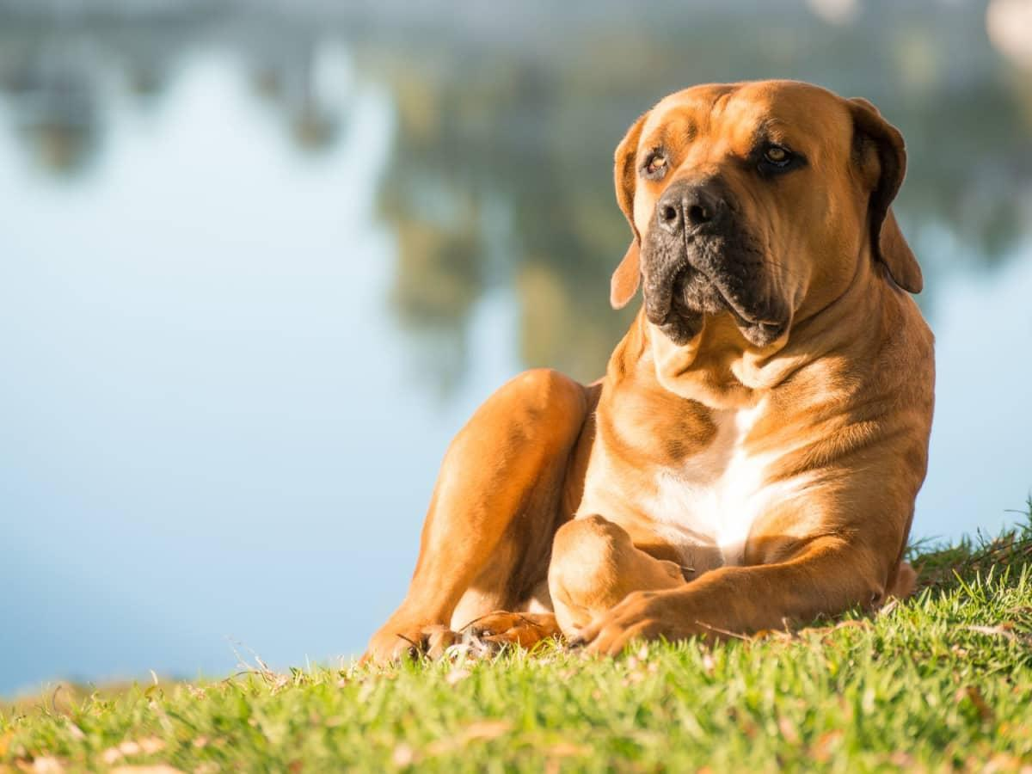

NAME:BOERBOEL

GROUP: Working (AKC)

HEIGHT: 22 to 27 inches  
WEIGHT: 150 to 200 pounds  
COAT AND COLOR: Short and dense coat that comes in shades of brown, red, and fawn; may have brindle or piebald markings

LIFE EXPECTANCY: 9 to 11 years

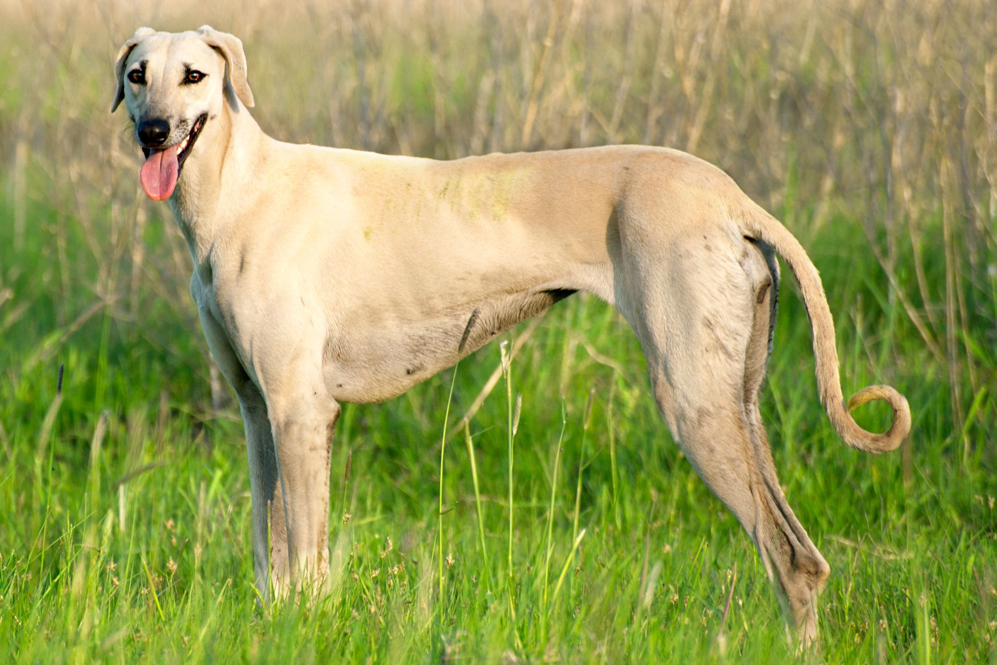NAME:SLOUGHI  
GROUP: Hound (AKC)

HEIGHT: 24 to 29 inches  
WEIGHT: 35 to 50 pounds  
COAT AND COLOR: Short hair; smooth coat; dark eyes; coat color includes all shades of cream to red; coat may have brindle or black markings around the eyes or ears

LIFE EXPECTANCY: 10 to 15 years

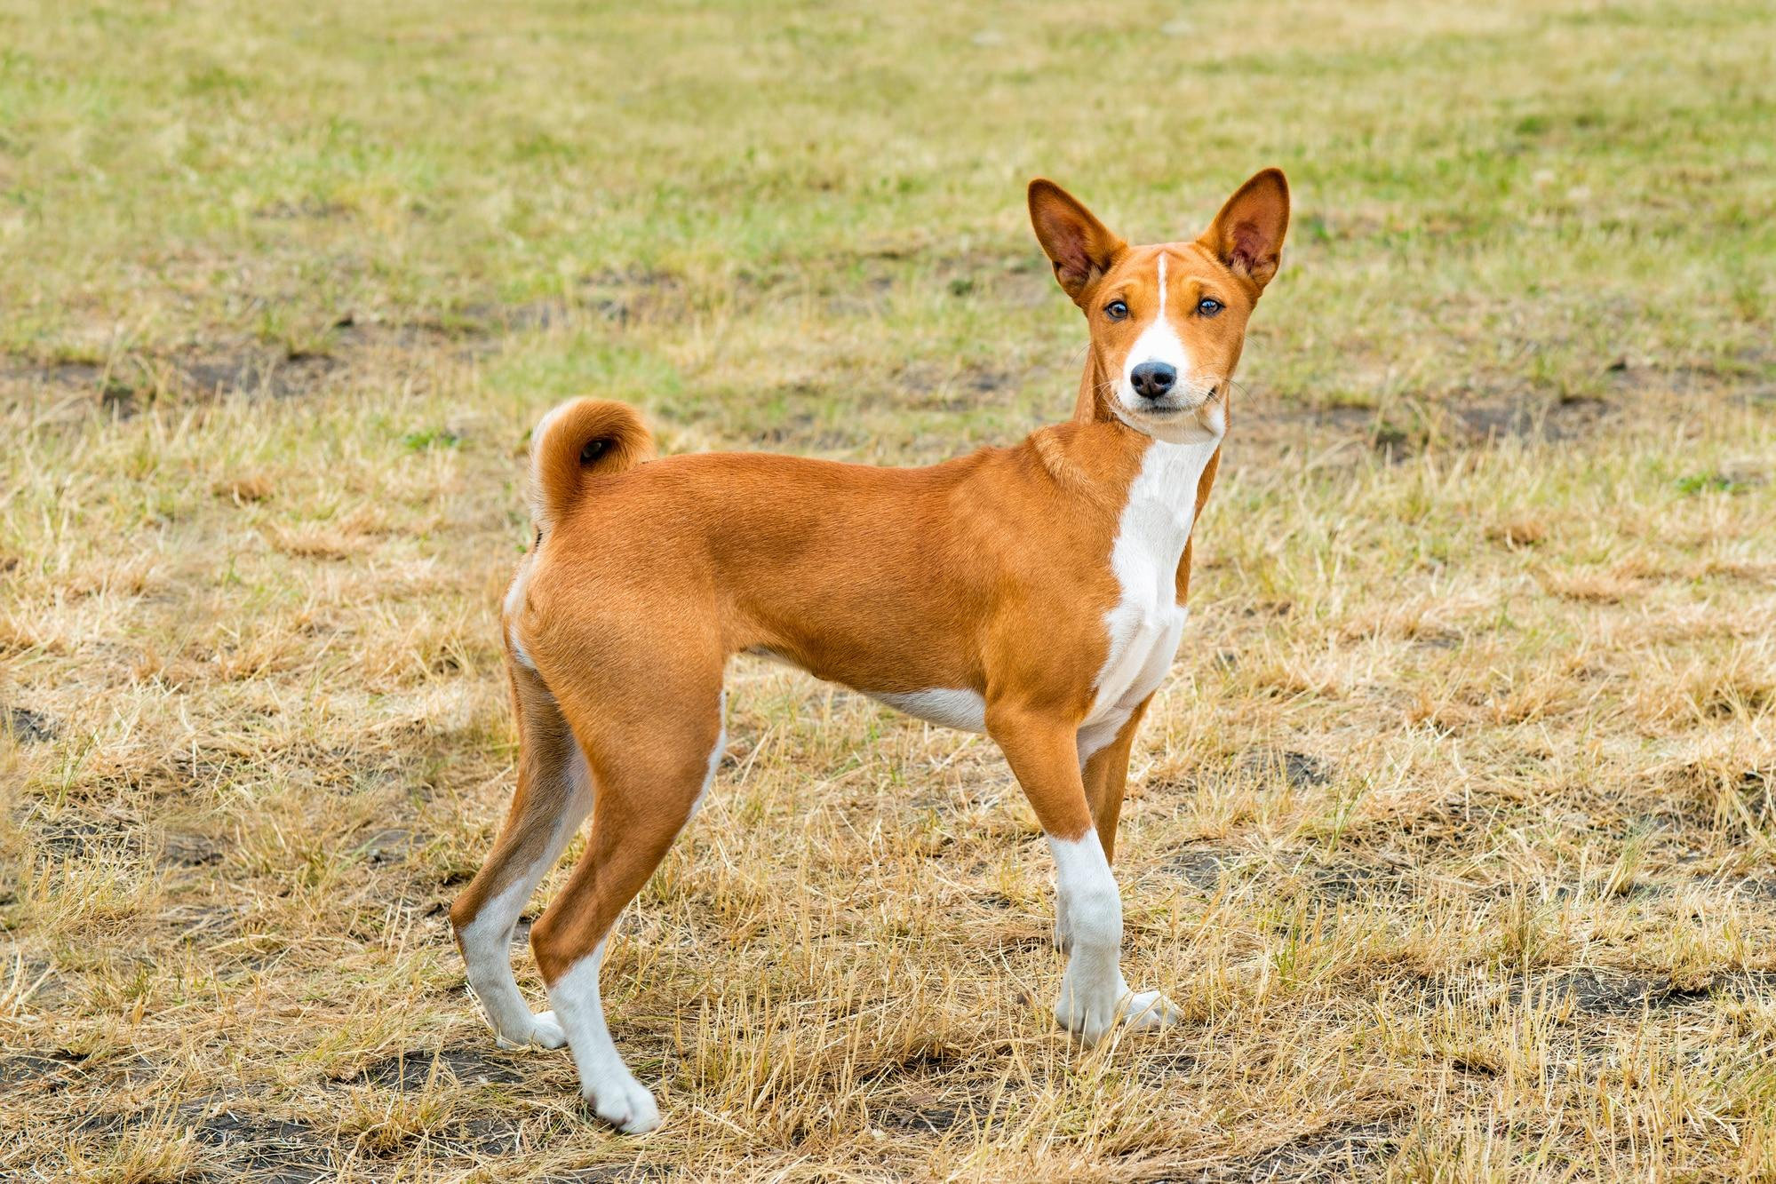  
NAME:BASENJI  
GROUP: Hound (AKC)

HEIGHT: 16 to 17 inches  
WEIGHT: 22 to 24 pounds  
COAT AND COLOR: Short, fine coat; colors include red, black, tricolor, or brindle with white markings on their feet, chest, and tail

LIFE EXPECTANCY: 13 to 14 years

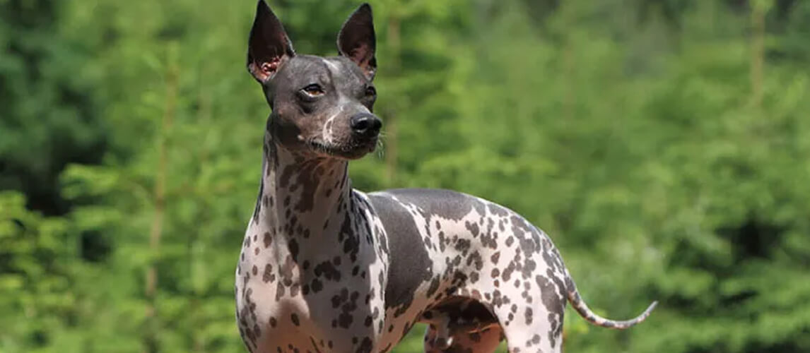

NAME:Abyssinian Sand Terrier

GROUP: Not an AKC-recognized breed; possibly extinct

HEIGHT: 15.5 to 20.5 inches  
WEIGHT: 21 to 39 pounds  
COAT AND COLOR: Colors include black, gray, bronze, sand; skin can have mottled markings; hairless except for some tufts of hair on head and tail

LIFE EXPECTANCY: 12 to 15 years